Elliot Anderson

Professor Blanche

CS 1030

5/5/23

CS Final Project

I chose the data set for why millions of Americans don't vote. This was on fivethirtyeight.gov

Hypothesis: the leading reason for Americans not voting is because they don't really care about it and that is due to them being young in age. Also income has to be a player as well.

Process: After putting the table into excel, I took the almost 7000 lines of data and put it into charts that I later compared to the ones on the website that I got the data from. These were the metadata from the website.

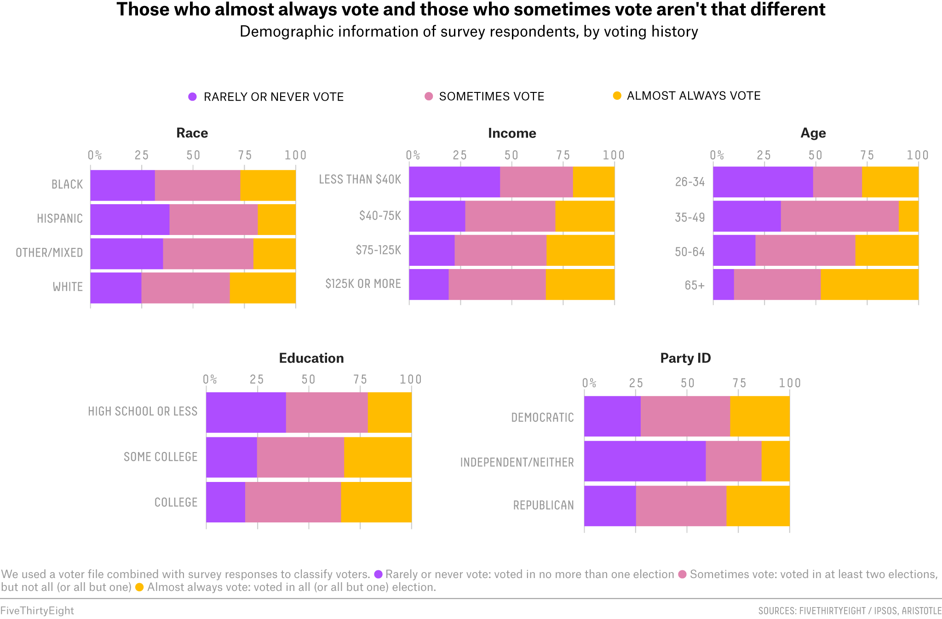

After comparing the two, while this one looks well more defined and mine was not as diverse as that. It is still similar nonetheless. Using the average function and the IF function, I came out with my own data. I did this for both the age and the income of average non voters. More detail of this includes downloading a zip file from fivethirtyeight.com. Then extracting it into excel. Data included but were not limited to age, sex, income, education ect. Through the average and if functions I got numbers. Then I compared those to the graphs to how I got my answers. For uploading I put it into a github repository and uploaded the link to canvas.

Data obtained: Data obtained was done through IPSOS for fivethirtyeight.

Results: As said before, after using both the average function in excel and the IF function in excel. It came out with data similar to the graph from the editor above. In the end Income AND Age both play a significant factor in non voters decisions to not vote in elections. Whileit is hard to prove causation there is definitely a correlation between those two.